Finance 517

Fluor Corporation: Construction Under Analysis
Paper by:

Daniel Eguina
Boris Gutman
Brent Wallace
Christina Wei
Martin Zapata

Contents
Executive Summary 4
I. Financial Analysis 5
II. Risk Profile Analysis 7
III. Stock Valuation 8
Appendix 1: Ratio Descriptions 10
APPENDIX 2 – Hand Calculated Fluor Ratio FYE 12/31/2011 11
APPENDIX 3 – Ratio Graphs with Trend Lines 12
Return on Assets Percentage 12
Return on Equity Percentage 12
Return on Investment Percentage 12
Earnings Before Interest, Taxes, Depreciation and Amortization Percentage 13
Quick Ratio 14
Current Ratio 14
Debt-to-Equity Ratio 15
Total Asset Turnover 15
Accounts Receivable Turnover 16
Cash Flow per Share 16
APPENDIX 4- Assumptions to Industry 17
Long term Debt 17
Receivables 17
APPENDIX 5 - Risk Analysis Calculations 18
Regression Analysis 18
Cost Of Equity 21
Equation 21
Variables 21
Output 21
Cost of Debt 21
APPENDIX 6 – Discounted Free Cashflow Model 22
APPENDIX 7 – Dividend Discount Model 22
REFERENCES 23
1) Fluor Corporation Form 10-K FYE December 31, 2011. SEC.gov article 23
2) Jacob’s Engineering Group Inc. 10-K FYE September 30, 2011. SEC.gov article. 23
3) SAIC, Inc. 10-K FYE January 31, 2012. SEC.gov article. 23
4) Wotapka, Dawn. Construction Industry Forecast to Rebound in 2010. Wall Street Journal. October 16, 2009. Online Article. 23

Executive Summary
Fluor Corporation provides construction services on massive scales to a wide range of customers, including government agencies. The construction industry is highly influenced by many economic factors that greatly impact the financial standing of the company. This report will review the last five years of Fluor financial statements to compare specific benchmarks against competitors, risk analysis for investment consideration, and valuation models to determine the strength of the company. Each part of the analysis will be used to determine whether or not we feel that Fluor currently presents itself as an attractive company for investors to invest in. The Appendices contain further notes that give insight to industry trends and assumptions as to why the financials became the way they were.
To better understand Fluor Corporation’s financial foundation, the following ratios are considered for the five most recent years of released financials ending in 2011 and compared against its two major competitors in the industry, SAIC and Jacobs Engineering. To measure comparative profitability, Return on Assets (ROA), Return on Equity (ROE), and the margin of Earnings Before Interest, Taxes, Depreciation and Amortization (EBITDA) for each company are considered. To measure their liquidity, a conservative approach is taken and the quick ratio is computed for comparison. Total debt to equity is used to understand each company’s debt management while total asset turnover and receivables turnover are used to assess a company’s asset management. Last but not least, cash flow per share is used to see how the market values each company’s ability to generate cash.

I. Financial Analysis
The calculation of Fluor’s ratios for year ending 12/31/2011 were derived using financials taken off the SEC Edgar website as shown in Appendix 2 but for consistency ratios taken from Mergent for all five years and for Fluor’s competitors were used (Appendix 3). Fluor’s ROA% reflects a positive relationship with the construction industry, drastically decreasing from 11.76% in 2008 to 4.83% in 2010. This negative trend was significantly impacted by the housing marketing drop and the world financial declines during this period. Fluor’s other financial statements show that the decrease in ROA was due to a decrease in revenue, thereby lowering net income. Although the ROA for fiscal year ending in 2011 recovered slightly (7.48%), the five-year trend line indicates a continued decrease in ROA%. Regardless of this trend in return, total assets for Fluor continued to grow steadily. In comparison with its competitors, the trend of ROA % remains similar however it was much more drastic for SAIC whose net income decreased by $560 million due to a decrease in continuing operations (SAIC Form 10-K FYE 2012, MD&A).
Compared to its nearest competitors in the industry, Fluor has a higher ROE% (Appendix 3), indicating that management is able to better utilize the company’s equity. The pattern of return mimics that of the ROA%. The housing and financial market volatility from 2008 to 2010 contributed to a negative trend line over the past five years. With an increased ROE% in their last fiscal year (from 10.51% to 17.23%), there is some optimism that Fluor’s management are finding ways to positively use the equity of the company.
Fluor’s EBITDA during the five years in general has a downward trend which suggests that the company’s profitability and cash flow generating ability is slightly compromised. However, by looking at the financials on the SEC Edgar site, one can note that Fluor had more than $21 million in interest income whereas JEC only had around $4 million in 2010 which is not reflected when calculating EBITDA. As shown in Appendix 3, the general trend of EBITDA across the industry was similar in exception to SAIC which grew in 2010 and dropped in 2011 to slightly below industry average. This can be explained in that SAIC’s business is aligned with different industry segments other than construction so it is possible that SAIC’s other operations carried the company during the dip in 2010 that affected those in the construction industry.
Further in defense, Fluor has a very solid quick ratio near 1 which suggests that the company is in good condition to pay off its current liabilities. However, when compared with its competitors whose quick ratios are more than one, it only shows that Fluor is more willing to invest its cash and liquid assets rather than holding on to them. Across the five years, the trend between the companies are similar. They all had larger quick ratios between the years 2008-2010 which dropped back down in 2011 which suggests the market is getting better as companies are less worried about holding liquid assets on hand to repay current liabilities.
Fluor’s total debt to equity ratio dipped slightly in 2008 through 2010 and rose back up to 16% in 2011. Given the market trends during 2008- 2010, Fluor was less aggressive in financing company growth using debt. In comparison with its competitors, the trend of debt utilization in financing is similar. Please note SAIC is heavily reliant on using debt to finance its operations. Thus, their ratios are higher than Fluor and Jacob’s. However, the aforementioned trends are consistent. (Please refer to Appendix 4 for further assumptions).
Fluor’s asset turnover is above its immediate competitors even if it decreased slightly in 2009 and 2010 and pulling up slightly in 2011. The industry ratios continued to decline between 2009-2011. This suggests that Fluor is more efficient in using its assets to generate sales. As for total receivables, the same trend is seen in Fluor which suggests that it is probably great at collecting its receivables in comparison to the industry. The industry is steady in collecting its receivables as well but their collection is not as good as Fluor’s. Please see Appendix 3 for ratios and trends and Appendix 4 for assumptions.
The cash flow per share ratio shows a sudden drop in 2010 but rebounded in 2011 but the general trend is still downward sloping. The industry’s financial strength dipped between 2009-2010 most likely due to the economy during that time which nearly decimated the construction industry (Wotapka). Fluor’s cash flow per share ratio is far above its competitors in the industry which suggests that the company is a more worthwhile investment as they are more likely to pay dividends.

II. Risk Profile Analysis
In order to analyze the riskiness of Fluor’s equity and ultimately its cost of equity, the Capital Asset Pricing Model (CAPM) was utilized. The first step was to run a regression analysis on Fluor’s stock return rate and market return rate to determine the risk of the company’s equity or Beta. The past five year’s (December 2007 thru November 2012) monthly stock price and S&P 500 index level was used to find Fluor’s monthly stock return rate and monthly market return rate. The regression analysis determined a Beta of 1.37 with a 95% confidence interval range of 0.93 to 1.81 and R2 value of 0.41. The Beta indicates that the market risk of the stock is fairly high, equivalent to the risk of the technology sector. The R2 from the regression model shows that 41% of the equity risk comes from the market while 59% of the risk is firm-specific and can be diversifiable.
The next step was to determine the cost of equity by using CAPM. The previously discussed Beta was used as well as the current 1.61% 10-year U.S. Treasury Bond rate for the risk free market rate. The market return rate was estimated to be 2.38% by calculating the total return over the past five years. Utilizing these numbers we determined a cost of equity of 2.66% with a confidence interval range of 2.33 to 3.00.
Fluor Corp. has a bond rating of A which puts their equivalent beta at 0.05 according to the S. Schaefer and I. Strebulaev, “Risk in Capital Structure Arbitrage”. The risk free rate of 1.61% and a market risk premium of 2.38% allow us to use CAPM to calculate the cost of debt as 1.73%. The capital structure for Fluor is setup to use equity as the primary form of capital funding with 13% being debt and 87% being equity.

III. Stock Valuation
In using the discounted free cash flow model, we obtained the weighted cost of capital (WACC) multiplying the cost of debt of 1.73% and cost of equity of 2.66% by their compositions of 13% and 87%, respectively, we obtained a rate of 2.54%. Stable growth was obtained by averaging the historical 5-year revenue growth of Fluor Corp.’s major competitors (Jacobs Engineering, Inc., SAIC Inc., and URS Corp.) to calculate a rate of 1.6%. Using Fluor Corp’s historical financial data from the past 5 years (2007-2011), we assumed an average growth rate for the 5-year forecast of 11.6%; cost of goods sold, operating expenses, capital expenditures, and net working capital based on historical percentage of revenue; and interest and depreciation expenses based on year 2011. The terminal value for year 2017 was obtained using the forecasted financials for year 2016 and the calculated stable growth and WACC rates. The forecasted FCFs and terminal value were discounted to year 2011 using the WACC as the discount rate. Diving the present value of the discounted FCFs and terminal value by the total outstanding shares for 2011 calculated a stock price of $376.69 (Appendix 6). This method, while provides a detailed analysis for the valuation of the stock price, has the optimistic assumption that the industry will, at one point in the near future, continue to grow at a stable rate. In comparison to the other valuation methods used, the discounted free cash flow model provides a much higher value for the stock price primarily due to the disparity between the assumed positive stable growth rate in this model and the negative dividend growth rate assumed in the dividend discount model.
In using the dividend discount model spanning back from 2006 to the present financial report, the stock price was calculated to be $13.23 given the negative growth of 9.44% due to the drop of dividend payout between 2007 and 2008. This provided stock price is on the lower spectrum in the pessimistic nature that there would be further dips in the industry. Since 2008, the dividend payout has stabilized. If it were to remain at this current rate, given the perpetuity formula, the company’s stock price should be $60.15 (Appendix 7).
IV. Conclusion
Looking at all of the financial information provided, an investor in the construction industry is encouraged to invest in Fluor Corporation. As one of the top players in the construction industry, Fluor has continually remained a steady forerunner in the industry despite the financial dip between 2007 and 2008. As mentioned, it looks like the industry is slowly recovering and thus the pessimism in stock prices may be unfounded. Although the company risk as calculated using CAPM is quite high, it is due to the nature of the industry and it is recommended for investors to properly diversify their investments.

Appendix 1: Ratio Descriptions
In amalgamation, the ratios addressed used give a good picture of how the chosen company is doing relative to its industry. For the most part, ratios that are more conservative were used to address concerns of risk averse investors.
The ROA ratio measures a company’s earnings per dollar of assets. Whereas the ROE incorporates ROA and determines the return a company earns in its investment (Berk & DeMarzo, 32). The EBITDA margin gives a rough measure of the cash a firm earns by each dollar of sales before interest, taxes, depreciation, and amortization. The quick ratio is a conservative measure of liquidity of a company and how capable they are to repay current liabilities. The total debt to equity ratio tells investors how aggressive a company is to finance its operations using debt. In layman terms, it is like a person using a credit card to pay his current finances except at a much higher amount and for a longer term of repayment. Total asset turnover helps investors determine how efficient a company is at using assets to maximize sales. On the other hand, receivables turnover shows if a company is efficient in collecting what is due to them, the higher the ratio the better. Last but not least, cash flow per share evaluates a company’s financial capabilities by looking at its operating cash flow net of preferred dividends per shares of common stock outstanding. This tells investors how much cash a company generates per share of common share.

APPENDIX 2 – Hand Calculated Fluor Ratio FYE 12/31/2011
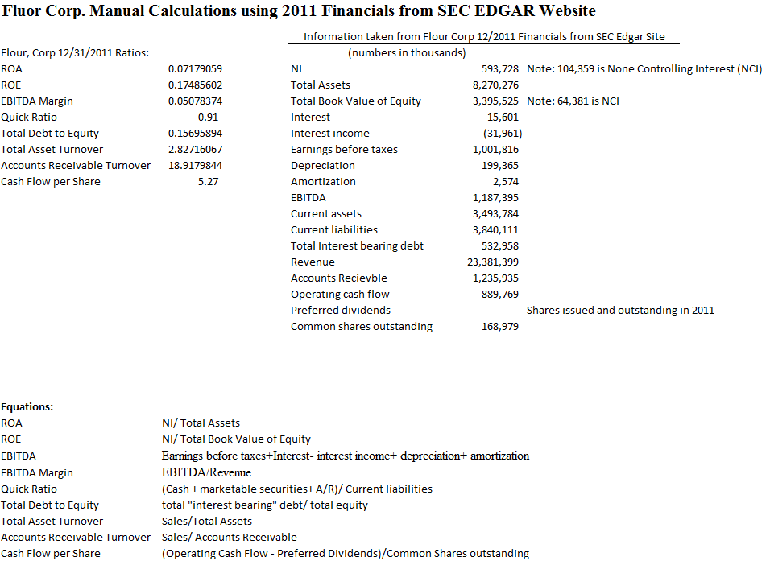

APPENDIX 3 – Ratio Graphs with Trend Lines

Return on Assets Percentage

Return on Equity Percentage

Return on Investment Percentage

Earnings Before Interest, Taxes, Depreciation and Amortization Percentage

Quick Ratio

Current Ratio

Debt-to-Equity Ratio

Total Asset Turnover

Accounts Receivable Turnover

Cash Flow per Share

APPENDIX 4- Assumptions to Industry
Due to the market crash in 2008 which severely affected the construction industry, the ratios changed dramatically during 2008-2010. From the industry ratios trending upward in 2011, it is assumed that the market is recovering slightly.

Long term Debt
With debt management there was a significant change in the total long term debt numbers between 2010 and 2011 increasing in approximately $500 million. From the cash flow statement, Fluor added approximately $495 million in senior notes which are notes that take priority over notes that are unsecured. Fluor has never done this in the five years studied which suggests that they are financing heavily in 2011. In 2011, Fluor also repurchased stocks about five times more than they did in prior years. Perhaps in an effort to reissue stocks at a different price.

Receivables
For receivables it is possible that due to the weak industry, vendors and clients of these companies would also suffer. Thus, it is plausible that due to this reason, the receivables turnover during those years decreased. The credit plan for the companies’ vendors and clients were probably more lenient to support ongoing relations during the hard times.

APPENDIX 5 - Risk Analysis Calculations

Regression Analysis
Time period | Price(Stock) | DPS(Stock) | Split Factor | S&P 500 Index Level | Return(Stock) | Return(Mkt)
12/3/2007 | 145.72 |  | 1 | 1468.36
1/2/2008 | 121.49 | 0.25 | 1 | 1378.55 | -0.164562174 | -0.065148163
2/1/2008 | 139.25 |  | 1 | 1330.63 | 0.146184871 | -0.036013016
3/3/2008 | 141.16 |  | 1 | 1322.7 | 0.013716338 | -0.005995313
4/1/2008 | 152.87 | 0.25 | 1 | 1385.59 | 0.084726551 | 0.045388607
5/1/2008 | 186.55 |  | 1 | 1400.38 | 0.220317917 | 0.010561419
6/2/2008 | 186.08 |  | 1 | 1280 | -0.002519432 | -0.094046875
7/1/2008 | 81.35 | 0.13 | 1.5 | 1267.38 | -0.343185727 | -0.00995755
8/1/2008 | 80.13 |  | 1 | 1282.83 | -0.014996927 | 0.012043685
9/2/2008 | 55.7 |  | 1 | 1166.36 | -0.304879571 | -0.099857677
10/1/2008 | 39.93 | 0.13 | 1 | 968.75 | -0.280789946 | -0.203984516
11/3/2008 | 45.54 |  | 1 | 896.24 | 0.140495868 | -0.080904668
12/1/2008 | 44.87 |  | 1 | 903.25 | -0.014712341 | 0.007760864
1/2/2009 | 38.9 | 0.13 | 1 | 825.88 | -0.130153778 | -0.093681891
2/2/2009 | 33.25 |  | 1 | 735.09 | -0.145244216 | -0.123508686
3/2/2009 | 34.55 |  | 1 | 797.87 | 0.039097744 | 0.078684497
4/1/2009 | 37.87 | 0.13 | 1 | 872.81 | 0.099855282 | 0.085860611
5/1/2009 | 46.98 |  | 1 | 919.14 | 0.24055981 | 0.050405814
6/1/2009 | 51.29 |  | 1 | 919.32 | 0.091741166 | 0.000195797
7/1/2009 | 52.8 | 0.13 | 1 | 987.48 | 0.031975044 | 0.069024183
8/3/2009 | 52.9 |  | 1 | 1020.62 | 0.001893939 | 0.032470459
9/1/2009 | 50.85 |  | 1 | 1057.08 | -0.038752363 | 0.03449124
10/1/2009 | 44.42 | 0.13 | 1 | 1036.19 | -0.123893805 | -0.020160395
11/2/2009 | 42.48 |  | 1 | 1095.63 | -0.043674021 | 0.054251892
12/1/2009 | 45.04 |  | 1 | 1115.1 | 0.060263653 | 0.017460317
1/4/2010 | 45.34 | 0.13 | 1 | 1073.87 | 0.009547069 | -0.038393847
2/1/2010 | 42.8 |  | 1 | 1104.49 | -0.056021173 | 0.027723203
3/1/2010 | 46.51 |  | 1 | 1169.43 | 0.086682243 | 0.055531327
4/1/2010 | 52.84 | 0.13 | 1 | 1186.69 | 0.138894861 | 0.014544658
5/3/2010 | 46.92 |  | 1 | 1089.41 | -0.112036336 | -0.089296041
6/1/2010 | 42.5 |  | 1 | 1030.71 | -0.094202899 | -0.056951034
7/1/2010 | 48.29 | 0.13 | 1 | 1101.6 | 0.139294118 | 0.064351852
8/2/2010 | 44.66 |  | 1 | 1049.33 | -0.075170843 | -0.049812738
9/1/2010 | 49.53 |  | 1 | 1141.2 | 0.109046126 | 0.080502979
10/1/2010 | 48.19 | 0.13 | 1 | 1183.26 | -0.024429639 | 0.035545865
11/1/2010 | 57.83 |  | 1 | 1180.55 | 0.200041502 | -0.00229554
12/1/2010 | 66.26 |  | 1 | 1257.64 | 0.145772091 | 0.061297351
1/3/2011 | 69.19 | 0.13 | 1 | 1286.12 | 0.046181708 | 0.022144123
2/1/2011 | 70.76 |  | 1 | 1327.22 | 0.02269114 | 0.030966984
3/1/2011 | 73.66 |  | 1 | 1325.83 | 0.040983607 | -0.0010484
4/1/2011 | 69.94 | 0.13 | 1 | 1363.61 | -0.048737442 | 0.027705869
5/2/2011 | 68.93 |  | 1 | 1345.2 | -0.014440949 | -0.013685697
6/1/2011 | 64.66 |  | 1 | 1320.64 | -0.061946903 | -0.018597044
7/1/2011 | 63.53 | 0.13 | 1 | 1292.28 | -0.015465512 | -0.021945708
8/1/2011 | 60.72 |  | 1 | 1218.89 | -0.044231072 | -0.060210519
9/1/2011 | 46.55 |  | 1 | 1131.42 | -0.233366271 | -0.077309929
10/3/2011 | 56.85 | 0.13 | 1 | 1253.3 | 0.22406015 | 0.097247267
11/1/2011 | 54.82 |  | 1 | 1246.96 | -0.035708004 | -0.005084365
12/1/2011 | 50.25 |  | 1 | 1257.6 | -0.083363736 | 0.00846056
1/3/2012 | 56.24 | 0.13 | 1 | 1312.41 | 0.121791045 | 0.041762864
2/1/2012 | 60.48 |  | 1 | 1365.68 | 0.075391181 | 0.039006209
3/1/2012 | 60.04 |  | 1 | 1408.47 | -0.007275132 | 0.030380484
4/2/2012 | 57.75 | 0.16 | 1 | 1397.91 | -0.035476349 | -0.007554134
5/1/2012 | 46.88 |  | 1 | 1310.33 | -0.188225108 | -0.066838125
6/1/2012 | 49.34 |  | 1 | 1362.16 | 0.052474403 | 0.038049862
7/2/2012 | 49.58 | 0.16 | 1 | 1379.32 | 0.008107013 | 0.012440913
8/1/2012 | 51.5 |  | 1 | 1406.58 | 0.038725292 | 0.019380341
9/4/2012 | 56.28 |  | 1 | 1440.67 | 0.092815534 | 0.023662601
10/1/2012 | 55.85 | 0.16 | 1 | 1412.16 | -0.004797441 | -0.02018893
11/1/2012 | 52.16 |  | 1 | 1379.85 | -0.06606983 | -0.023415589

Cost Of Equity

Equation
- R_{i} = R_{f} + Beta(R_{m}-R_{f})

Variables
- Beta = 1.37
- Beta Lower (95%) = 0.93
- Beta Upper (95%) = 1.91
- R_{f} = 1.61%
- R_{m} = 2.38%

Output
- R_{i} (Beta) = 2.66%
- R_{i} (Beta Lower Range) = 2.32%
- R_{i} (Beta Upper Range) = 3.00%

Cost of Debt
- Beta = 0.05
- R_{f} = 1.61 (10-yr U.S. Bond Rate)
- R_{m} = 2.38 (S&P 500 Return from 1/2008-10/2012)
- Cost of Debt = 1.61% + 0.05 (2.38%)
- Cost of Debt = 1.73%

APPENDIX 6 – Discounted Free Cash Flow Model
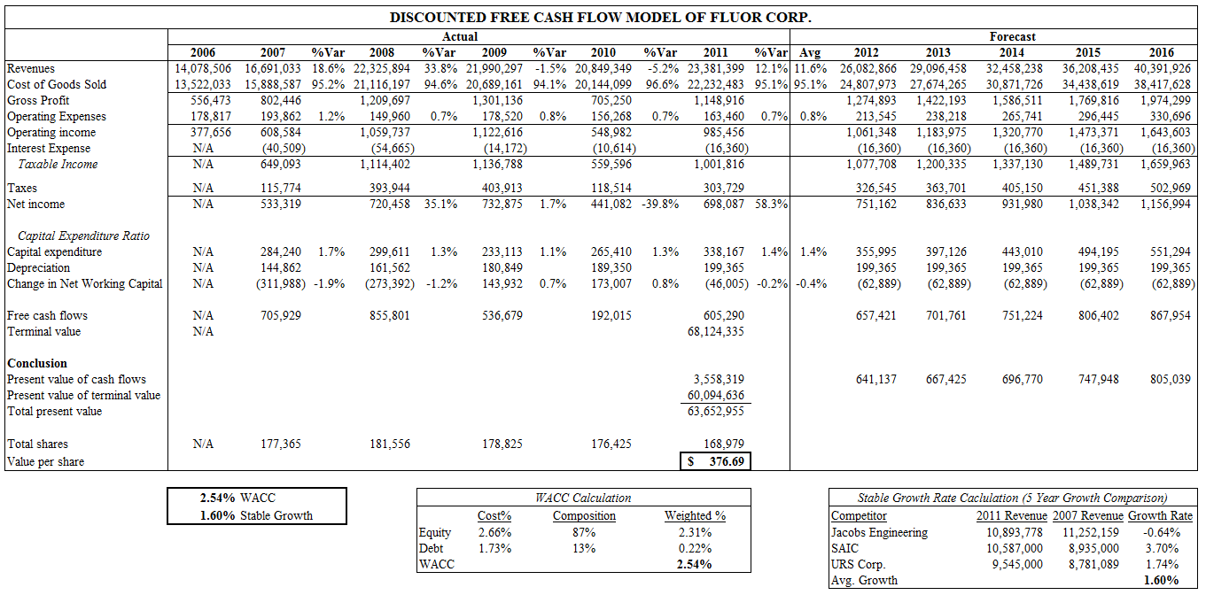
APPENDIX 7 – Dividend Discount Model
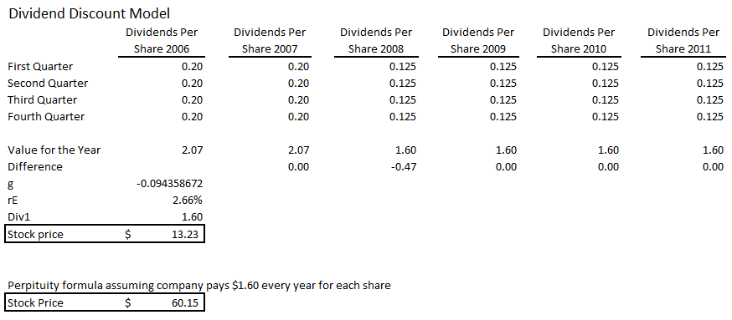

REFERENCES

1) Fluor Corporation Form 10-K FYE December 31, 2011. SEC.gov article

2) Jacob’s Engineering Group Inc. 10-K FYE September 30, 2011. SEC.gov article.

3) SAIC, Inc. 10-K FYE January 31, 2012. SEC.gov article.

4) Wotapka, Dawn. Construction Industry Forecast to Rebound in 2010. Wall Street Journal. October 16, 2009. Online Article.

