Risk Profile Analysis

In order to analyze the riskiness of Fluor’s equity and ultimately its cost of equity, the Capital Asset Pricing Model (CAPM) was utilized. The first step was to run a regression analysis on Fluor’s stock return rate and market return rate to determine the risk of the company’s equity or Beta. The past five year’s (December 2007 thru November 2012) monthly stock price and S&P 500 index level was used to find Fluor’s monthly stock return rate and monthly market return rate. The regression analysis determined a Beta of 1.37 with a 95% confidence interval range of 0.93 to 1.81 and R² value of 0.41. The Beta indicates that the market risk of the stock is fairly high, equivalent to the risk of the technology sector. The R² from the regression model shows that 41% of the equity risk comes from the market while 59% of the risk is firm-specific and can be diversifiable.
The next step was to determine the cost of equity by using CAPM. The previously discussed Beta was used as well as the current 1.61% 10-year U.S. Treasury Bond rate for the risk free market rate. The market return rate was estimated to be 2.38% by calculating the total return over the past five years. Utilizing these numbers we determined a cost of equity of 2.66% with a confidence interval range of 2.33 to 3.00.
Fluor Corp. has a bond rating of A which puts their equivalent beta at 0.05 according to the S. Schaefer and I. Strebulaev, “Risk in Capital Structure Arbitrage”. The risk free rate of 1.61% and a market risk premium of 2.38% allow us to use CAPM to calculate the cost of debt as 1.73%. The capital structure for Fluor is set up to use equity as the primary form of capital funding with 13% being debt and 87% being equity.

Appendix A – Risk Analysis Calculations
Regression Analysis:
Time period | Price(Stock) | DPS(Stock) | Split Factor | S&P 500 Index Level | Return(Stock) | Return(Mkt)
12/3/2007 | 145.72 |  | 1 | 1468.36
1/2/2008 | 121.49 | 0.25 | 1 | 1378.55 | -0.164562174 | -0.065148163
2/1/2008 | 139.25 |  | 1 | 1330.63 | 0.146184871 | -0.036013016
3/3/2008 | 141.16 |  | 1 | 1322.7 | 0.013716338 | -0.005995313
4/1/2008 | 152.87 | 0.25 | 1 | 1385.59 | 0.084726551 | 0.045388607
5/1/2008 | 186.55 |  | 1 | 1400.38 | 0.220317917 | 0.010561419
6/2/2008 | 186.08 |  | 1 | 1280 | -0.002519432 | -0.094046875
7/1/2008 | 81.35 | 0.13 | 1.5 | 1267.38 | -0.343185727 | -0.00995755
8/1/2008 | 80.13 |  | 1 | 1282.83 | -0.014996927 | 0.012043685
9/2/2008 | 55.7 |  | 1 | 1166.36 | -0.304879571 | -0.099857677
10/1/2008 | 39.93 | 0.13 | 1 | 968.75 | -0.280789946 | -0.203984516
11/3/2008 | 45.54 |  | 1 | 896.24 | 0.140495868 | -0.080904668
12/1/2008 | 44.87 |  | 1 | 903.25 | -0.014712341 | 0.007760864
1/2/2009 | 38.9 | 0.13 | 1 | 825.88 | -0.130153778 | -0.093681891
2/2/2009 | 33.25 |  | 1 | 735.09 | -0.145244216 | -0.123508686
3/2/2009 | 34.55 |  | 1 | 797.87 | 0.039097744 | 0.078684497
4/1/2009 | 37.87 | 0.13 | 1 | 872.81 | 0.099855282 | 0.085860611
5/1/2009 | 46.98 |  | 1 | 919.14 | 0.24055981 | 0.050405814
6/1/2009 | 51.29 |  | 1 | 919.32 | 0.091741166 | 0.000195797
7/1/2009 | 52.8 | 0.13 | 1 | 987.48 | 0.031975044 | 0.069024183
8/3/2009 | 52.9 |  | 1 | 1020.62 | 0.001893939 | 0.032470459
9/1/2009 | 50.85 |  | 1 | 1057.08 | -0.038752363 | 0.03449124
10/1/2009 | 44.42 | 0.13 | 1 | 1036.19 | -0.123893805 | -0.020160395
11/2/2009 | 42.48 |  | 1 | 1095.63 | -0.043674021 | 0.054251892
12/1/2009 | 45.04 |  | 1 | 1115.1 | 0.060263653 | 0.017460317
1/4/2010 | 45.34 | 0.13 | 1 | 1073.87 | 0.009547069 | -0.038393847
2/1/2010 | 42.8 |  | 1 | 1104.49 | -0.056021173 | 0.027723203
3/1/2010 | 46.51 |  | 1 | 1169.43 | 0.086682243 | 0.055531327
4/1/2010 | 52.84 | 0.13 | 1 | 1186.69 | 0.138894861 | 0.014544658
5/3/2010 | 46.92 |  | 1 | 1089.41 | -0.112036336 | -0.089296041
6/1/2010 | 42.5 |  | 1 | 1030.71 | -0.094202899 | -0.056951034
7/1/2010 | 48.29 | 0.13 | 1 | 1101.6 | 0.139294118 | 0.064351852
8/2/2010 | 44.66 |  | 1 | 1049.33 | -0.075170843 | -0.049812738
9/1/2010 | 49.53 |  | 1 | 1141.2 | 0.109046126 | 0.080502979
10/1/2010 | 48.19 | 0.13 | 1 | 1183.26 | -0.024429639 | 0.035545865
11/1/2010 | 57.83 |  | 1 | 1180.55 | 0.200041502 | -0.00229554
12/1/2010 | 66.26 |  | 1 | 1257.64 | 0.145772091 | 0.061297351
1/3/2011 | 69.19 | 0.13 | 1 | 1286.12 | 0.046181708 | 0.022144123
2/1/2011 | 70.76 |  | 1 | 1327.22 | 0.02269114 | 0.030966984
3/1/2011 | 73.66 |  | 1 | 1325.83 | 0.040983607 | -0.0010484
4/1/2011 | 69.94 | 0.13 | 1 | 1363.61 | -0.048737442 | 0.027705869
5/2/2011 | 68.93 |  | 1 | 1345.2 | -0.014440949 | -0.013685697
6/1/2011 | 64.66 |  | 1 | 1320.64 | -0.061946903 | -0.018597044
7/1/2011 | 63.53 | 0.13 | 1 | 1292.28 | -0.015465512 | -0.021945708
8/1/2011 | 60.72 |  | 1 | 1218.89 | -0.044231072 | -0.060210519
9/1/2011 | 46.55 |  | 1 | 1131.42 | -0.233366271 | -0.077309929
10/3/2011 | 56.85 | 0.13 | 1 | 1253.3 | 0.22406015 | 0.097247267
11/1/2011 | 54.82 |  | 1 | 1246.96 | -0.035708004 | -0.005084365
12/1/2011 | 50.25 |  | 1 | 1257.6 | -0.083363736 | 0.00846056
1/3/2012 | 56.24 | 0.13 | 1 | 1312.41 | 0.121791045 | 0.041762864
2/1/2012 | 60.48 |  | 1 | 1365.68 | 0.075391181 | 0.039006209
3/1/2012 | 60.04 |  | 1 | 1408.47 | -0.007275132 | 0.030380484
4/2/2012 | 57.75 | 0.16 | 1 | 1397.91 | -0.035476349 | -0.007554134
5/1/2012 | 46.88 |  | 1 | 1310.33 | -0.188225108 | -0.066838125
6/1/2012 | 49.34 |  | 1 | 1362.16 | 0.052474403 | 0.038049862
7/2/2012 | 49.58 | 0.16 | 1 | 1379.32 | 0.008107013 | 0.012440913
8/1/2012 | 51.5 |  | 1 | 1406.58 | 0.038725292 | 0.019380341
9/4/2012 | 56.28 |  | 1 | 1440.67 | 0.092815534 | 0.023662601
10/1/2012 | 55.85 | 0.16 | 1 | 1412.16 | -0.004797441 | -0.02018893
11/1/2012 | 52.16 |  | 1 | 1379.85 | -0.06606983 | -0.023415589

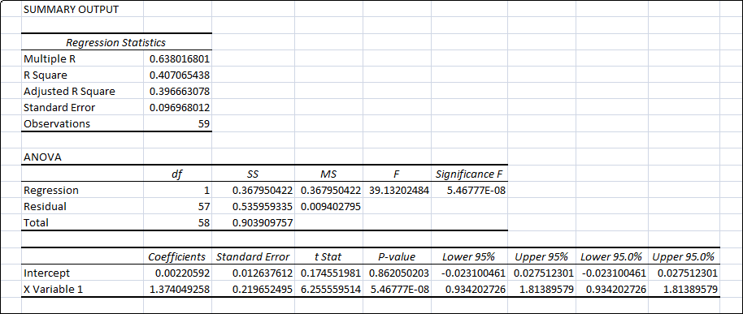
Cost Of Equity:
Equation:
R_{i} = R_{f} + Beta(R_{m}-R_{f})

Variables:
Beta = 1.37
Beta Lower (95%) = 0.93
Beta Upper (95%) = 1.91
R_{f} = 1.61%
R_{m} = 2.38%

Output:
Ri (Beta) = 2.66%
Ri (Beta Lower Range) = 2.32%
Ri (Beta Upper Range) = 3.00%

